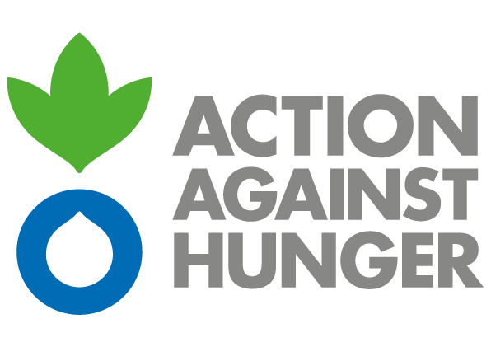
Action Against Hunger
Mission Philippines

ADVERTISEMENT

CALL FOR TENDERS – FRAMEWORK AGREEMENT CONTRACT FOR VEHICLE RENTAL/TRANSPORT SERVICES

PH-ML-07631

Action Against Hunger is an international and independent nongovernmental humanitarian organization that tackles the causes and effects of hunger and diseases that threaten the lives of vulnerable children, women and men. It has been present in the Philippines since 2000, giving response to natural and man-made crisis like Yolanda or Marawi.
Action Against Hunger - Philippines intends to award one or several Framework Agreement contracts with duration of one year extendable to another one for the supply of vehicle rental services in the framework of humanitarian programs.
The organization wants to encourage all possible suppliers to participate in the process regardless of their geographical scope and fleet size.
Bidding documents with the details and instructions of this process can be obtained by interested parties before Friday, January 31st at 5:00 pm from:

Mr. Alvaro Munoz
Logistics Assistant
Tel.: (+63) 9182080941
amunozdepablo@ph.acfspain.org

or at the below address between 9:00 am - 5:00 pm:

Action Against Hunger – Mission Philippines
4th Floor, Eurovilla 4 Building, 853 A. Arnaiz St. Legaspi Village
Makati City, Philippines 1229

The deadline for the submission of offers is Wednesday, February 19th at 5:00 pm.
Action Against Hunger does not bind itself to award the tender to the lowest tender or any bid and reserves the right to accept the whole or part of the tender.

