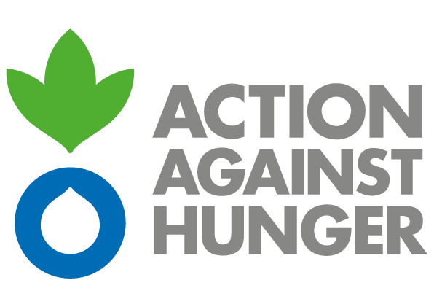
Action Against Hunger
Mission Philippines

ADVERTISEMENT

CALL FOR TENDERS – LONG-TERM FRAMEWORK AGREEMENT FOR THE SUPPLY OF EMERGENCY RESPONSE KITS

PH-ML-08255

Action Against Hunger is an international and independent non-governmental humanitarian organization that addresses the root causes and effects of hunger and diseases that threaten the lives of vulnerable children, women, and men. The organization has been operational in the Philippines since 2000, providing assistance in response to natural and man-made crises.

Action Against Hunger - Philippines is planning to award one or more Framework Agreement contracts for the supply of emergency response items and kits for a duration of one year, which may be extendable for another year in the context of its humanitarian programs.

The organization aims to encourage all local/national potential suppliers, regardless of their geographical scope, to participate in the procurement process.

Bidding documents with the details and instructions of this process can be obtained by interested parties until Wednesday, May 17^{th,} 2023 at 5:00 pm from:

Mr. Christian Rodolf Misagal
Logistics Coordinator
Tel.: (+63) 9957211196
cmisagal@ph.acfspain.org

or at the below address between 9:00 am - 5:00 pm:

Action Against Hunger – Mission Philippines
4th Floor, Gloria Building, 109 Aguirre St., Legaspi Village
Makati City, Philippines 1229

The deadline for the submission of offers is Friday, June 9th 2023 at 5:00 pm.
Action Against Hunger does not bind itself to award the tender to the lowest tender or any bid and reserves the right to accept the whole or part of the tender.

